TASK 2: SQL QUERIES
DONE BY: Dharshini K
DATE: 28.04.2026

BASICS
QUESTION 1: List all customers from USA.
ANSWER: SELECT * FROM Customers WHERE Country = 'USA';
OUTPUT:
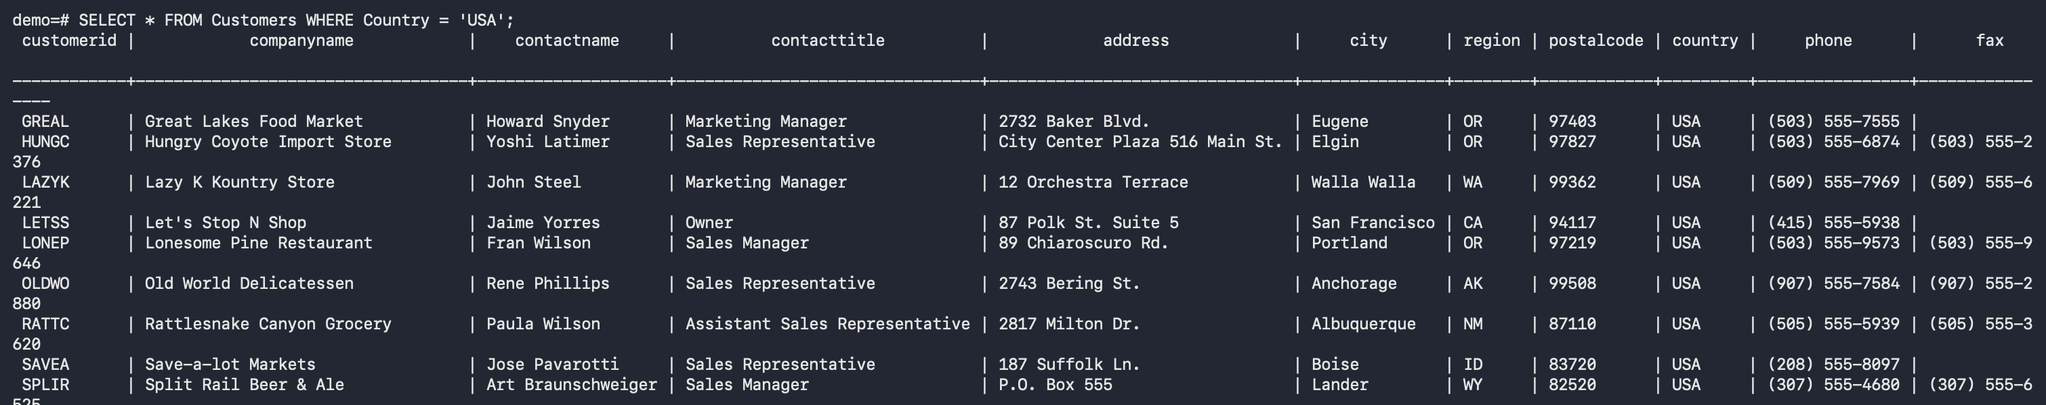

QUESTION 2: List all products where UnitPrice is greater than 20.
ANSWER: SELECT * FROM Products WHERE UnitPrice > 20;
OUTPUT:
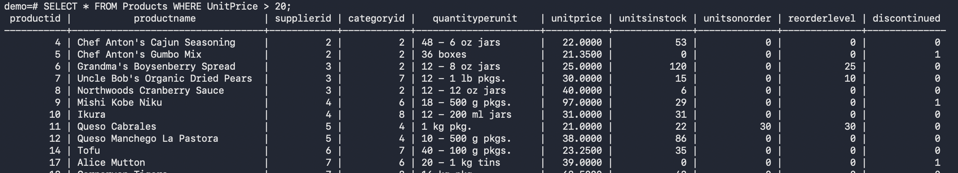

QUESTION 3: List all orders placed after 1997-01-01.
ANSWER: SELECT * FROM Orders WHERE orderdate > '1997-01-01';
OUTPUT:
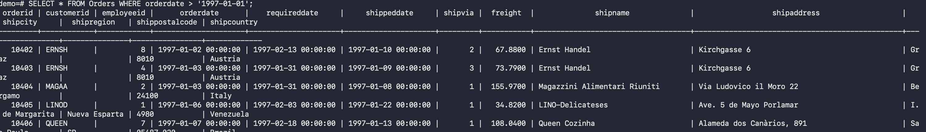

QUESTION 4: Display customers ordered by Country and then CompanyName.
ANSWER: SELECT * FROM Customers ORDER BY Country, CompanyName;
OUTPUT:
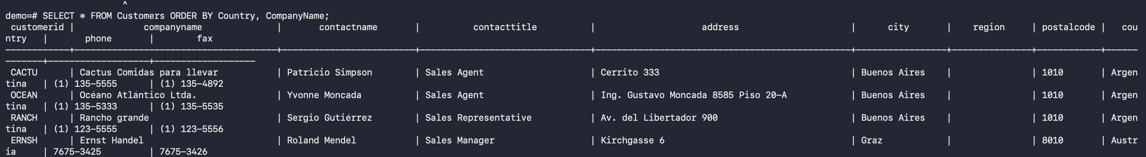

QUESTION 5: List products ordered by highest UnitPrice first.
ANSWER: SELECT * FROM Products ORDER BY UnitPrice DESC;
OUTPUT:
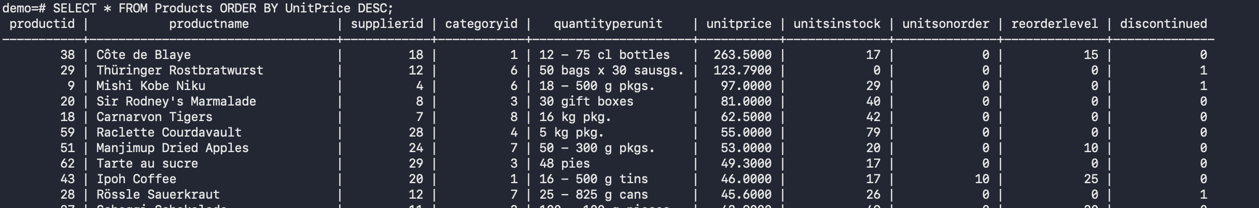

GROUP BY

QUESTION6: Count how many customers are there in each country.
ANSWER: SELECT Country, COUNT(*) AS customer_count FROM Customers GROUP BY Country;
OUTPUT:
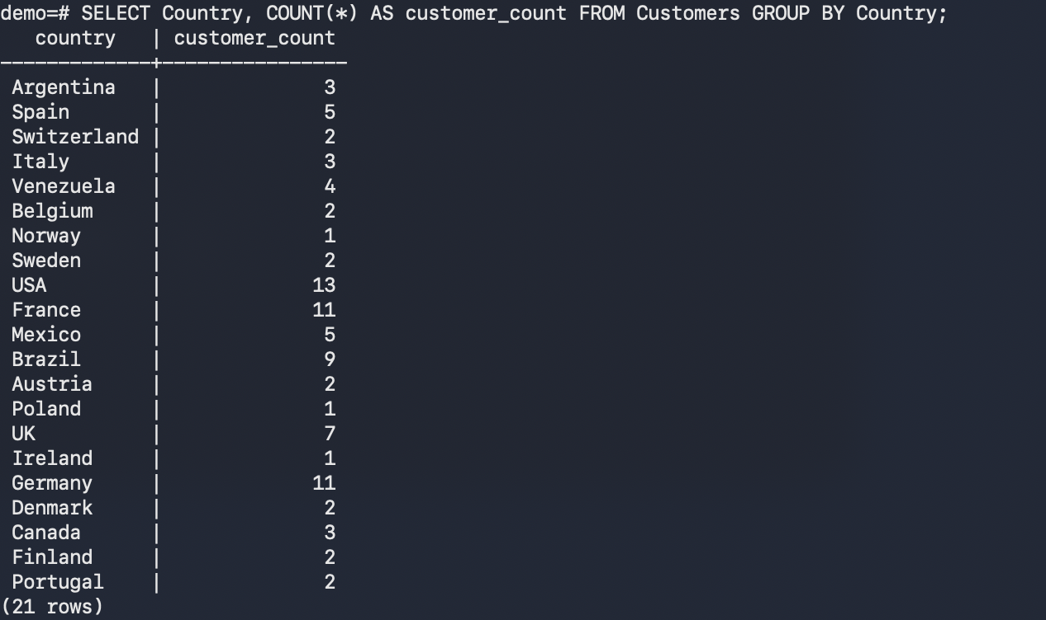
QUESTION 7: Find the number of products in each category.
ANSWER:
SELECT c.categoryname, COUNT(p.categoryid)
FROM Products p JOIN categories c ON p.categoryid = c.categoryid
GROUP BY c.categoryname;
OUTPUT:
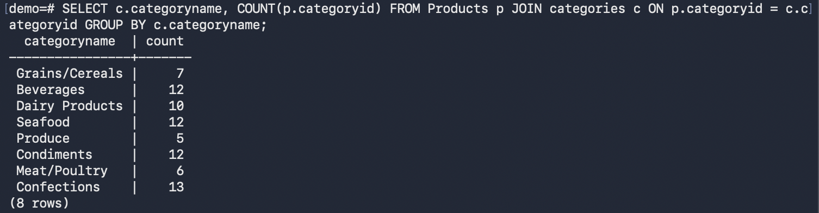

QUESTION 8: Find the total number of orders handled by each employee.
ANSWER:
SELECT e.firstname, COUNT(o.orderid) AS Total_Orders
FROM Employees e JOIN Orders o ON e.employeeid = o. employeeid
GROUP BY e.firstname, e.lastname;
OUTPUT:
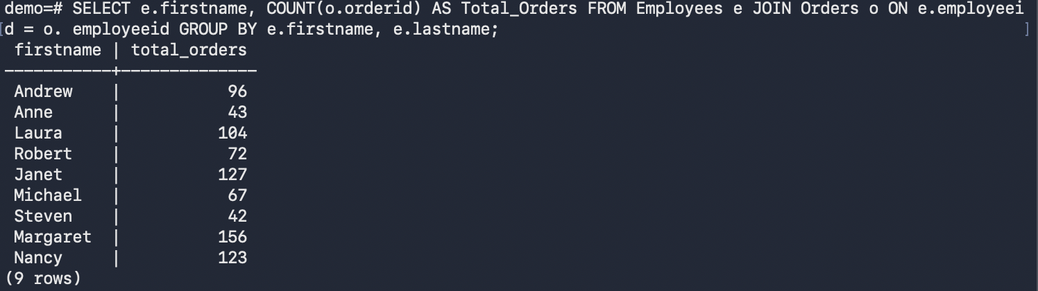

QUESTION 9: Find the average freight amount for each customer.
ANSWER:
SELECT customerid, AVG(freight) AS Avg_Freight FROM Orders GROUP BY customerid;
OUTPUT:
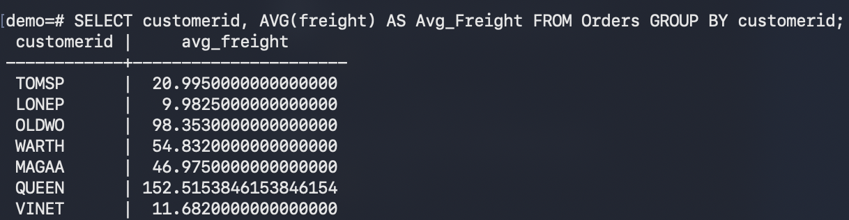

QUESTION 10: Find the maximum unit price in each category.
ANSWER:
SELECT c.categoryname, MAX(p.UnitPrice) FROM Products p JOIN Categories c ON p.categoryid = c.categoryid GROUP BY c.categoryname;
OUTPUT:
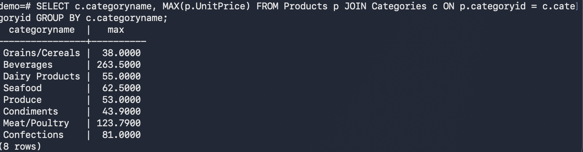

HAVING
QUESTION 11: Show countries having more than 5 customers.
ANSWER:
SELECT Country FROM Customers GROUP BY Country HAVING COUNT(Customerid) > 5;
OUTPUT:
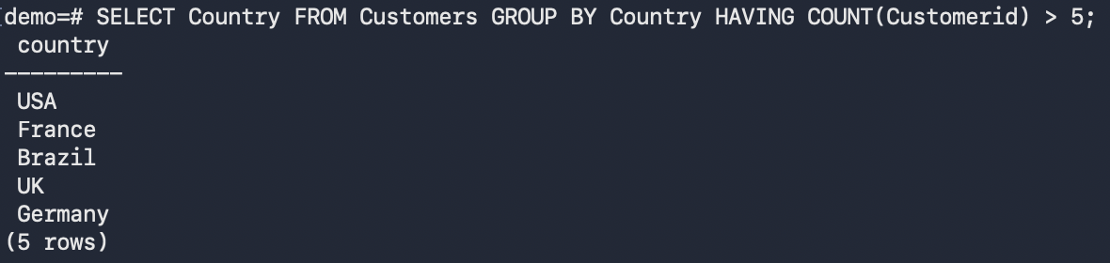

QUESTION 12: Show employees who handled more than 50 orders.
ANSWER:
SELECT e.firstname, e.lastname, COUNT(o.orderid) AS Total_Orders
FROM Employees e JOIN Orders o ON e.employeeid = o.employeeid
GROUP BY e.firstname, e.lastname
HAVING COUNT(o.orderid) > 50;
OUTPUT:
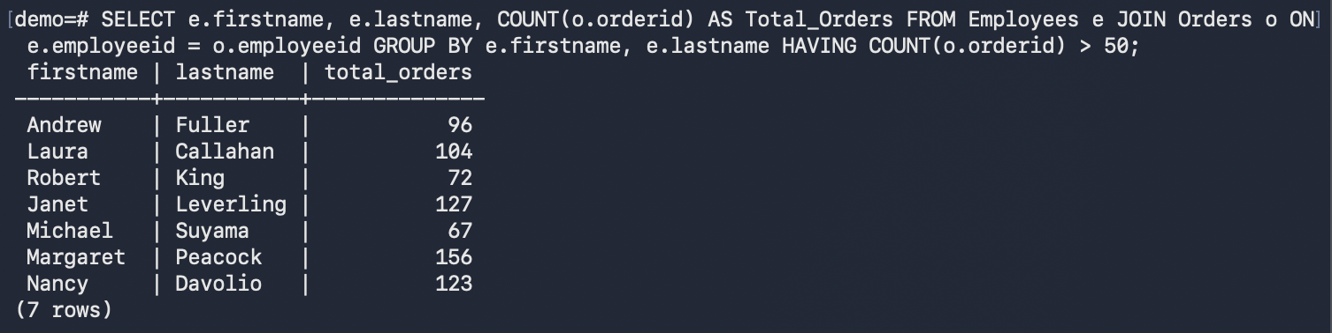

QUESTION 13: Show customers whose average freight is greater than 50.
ANSWER:
SELECT customerid, AVG(freight) AS Avg_Freight
FROM Orders
GROUP BY customerid
HAVING AVG(freight) > 50;
OUTPUT:
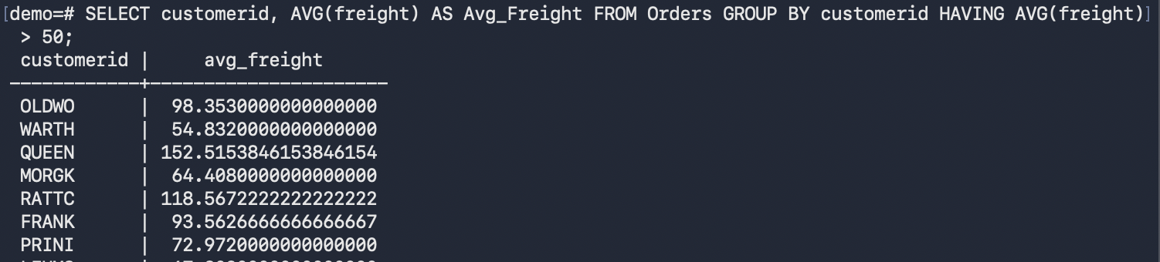

QUESTION 14: Show categories where the average product price is greater than 30.
ANSWER:
SELECT c.categoryname, AVG(p.UnitPrice) FROM Categories c JOIN Products p ON c.categoryid = p.categoryid GROUP BY c.categoryname HAVING AVG(p.UnitPrice) > 30;
OUTPUT:
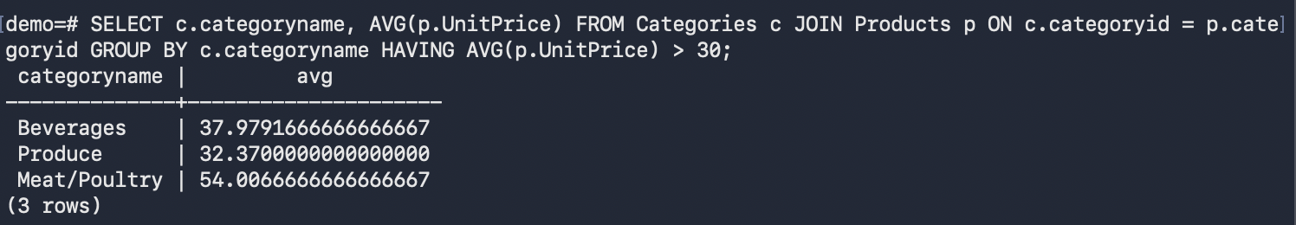

QUESTION 15: Show ship countries having more than 20 orders.
ANSWER:
SELECT shipcountry, COUNT(*) AS No_Of_Orders FROM ORDERS GROUP BY shipcountry HAVING COUNT(*) > 20;
OUTPUT:
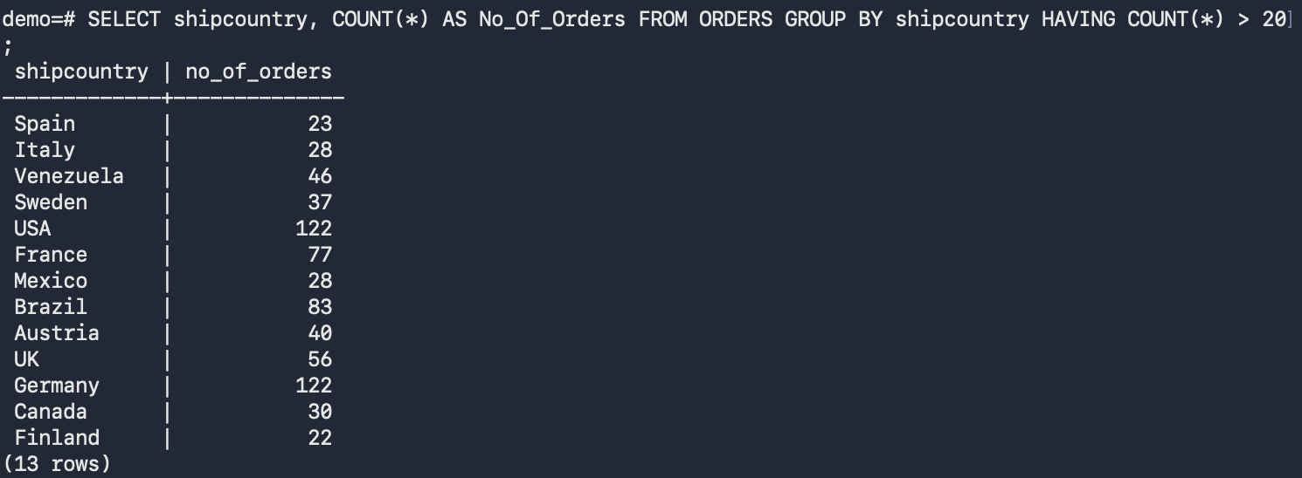

JOINS
QUESTION 16: List each order with customer company name.
ANSWER:
SELECT o.orderid,c.CompanyName,o.orderdate,o.shippeddate,o.freight
FROM Orders o JOIN Customers c
ON o.customerid = c.customerid;
OUTPUT:
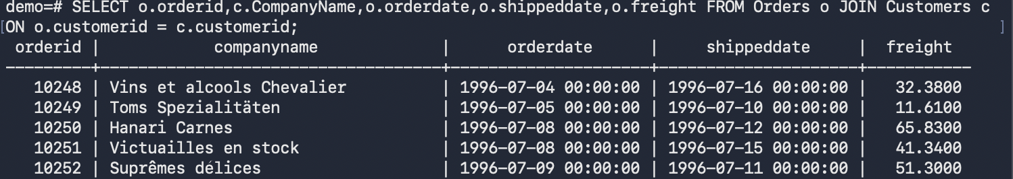

QUESTION 17: List each order with employee first name and last name.
ANSWER:
SELECT e.firstname, e.lastname, o.orderid FROM Employees e JOIN Orders o ON e.employeeid = o.employeeid;
OUTPUT:
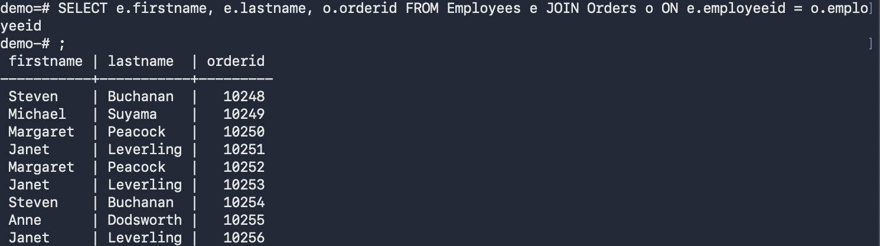

QUESTION 18: List products with their category name.
ANSWER:
SELECT c.categoryname, p.productid, p.productname
FROM Categories c JOIN Products p
ON c.categoryid = p.categoryid;
OUTPUT:
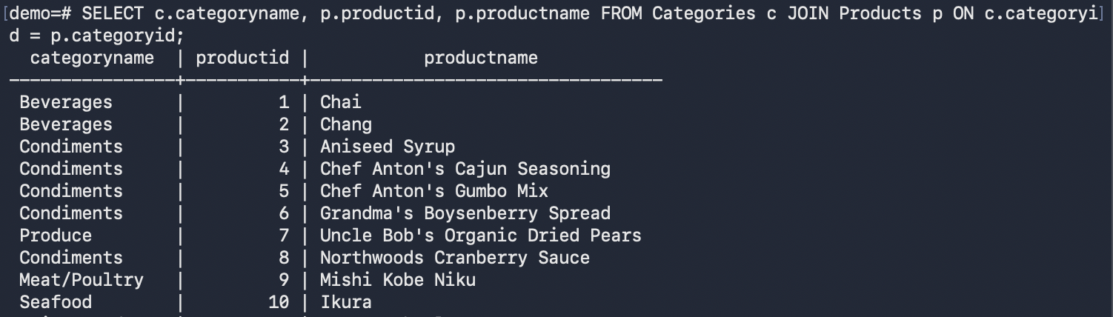

QUESTION 19: List products with supplier company name.
ANSWER:
SELECT s.companyname, p.productname
FROM Suppliers s JOIN Products p
ON s.supplierid = p.supplierid;
OUTPUT:
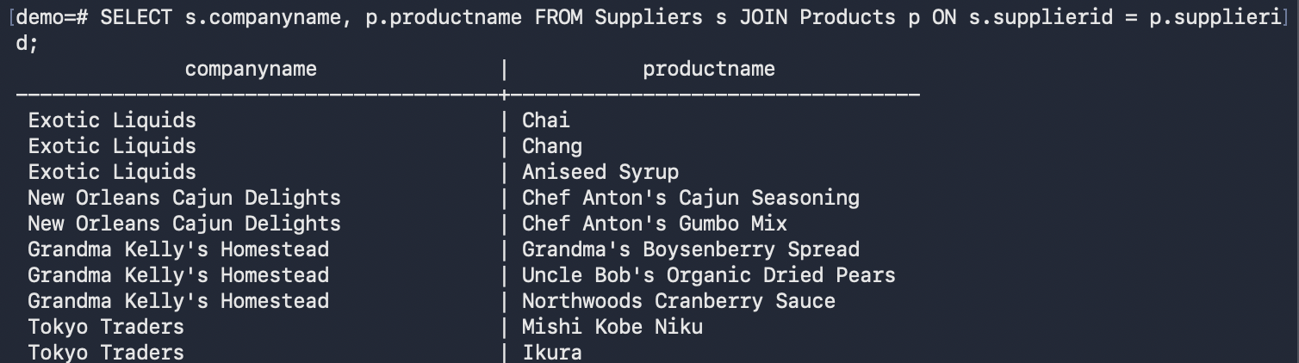

QUESTION 20: List orders with shipper company name.
ANSWERS:
SELECT o.orderid, s.companyname
FROM Orders o JOIN Shippers s
ON o.shipvia = s.shipperid;
OUTPUT:
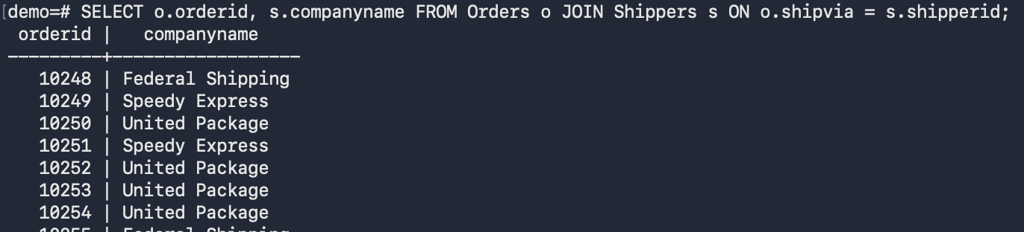

MEDIUM
QUESTION 21: Find total orders per customer and display customer company name.
ANSWER:
SELECT c.companyname, COUNT(o.orderid) AS Total_Orders
FROM Customers c JOIN Orders o ON c.Customerid = o.Customerid
GROUP BY c.companyname;
OUTPUT:
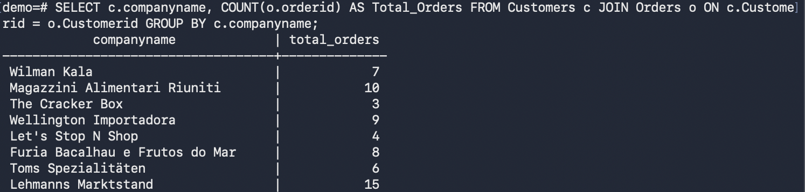

QUESTION 22: Find total products supplied by each supplier.
ANSWER:
SELECT s.companyname, COUNT(p.productid)
FROM Suppliers s JOIN Products p
ON s.supplierid = p.supplierid
GROUP BY s.companyname;
OUTPUT:
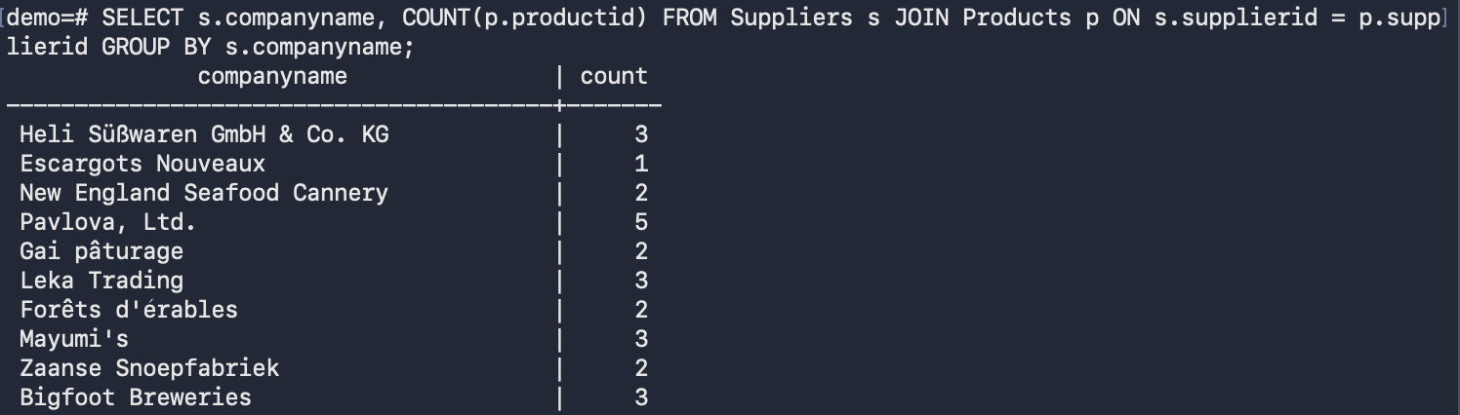

QUESTION 23: Find average product price per category with category name.
ANSWER:
SELECT c.CategoryName , AVG(p.UnitPrice) AS AVG_PRODUCT_PRICE
FROM Categories c JOIN Products p
ON c.categoryid = p.categoryid
GROUP BY c.CategoryName;
OUTPUT:
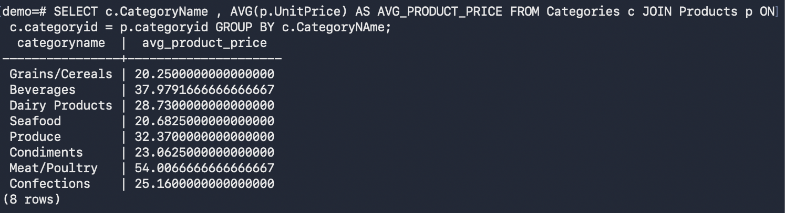

QUESTION 24: Find total freight per customer and order by highest total freight.
ANSWER:
SELECT c.CompanyName, SUM(o.freight) AS total_freight
FROM Customers c JOIN Orders o
ON c.customerid = o.customerid
GROUP BY c.CompanyName
ORDER BY SUM(o.freight) DESC;
OUTPUT:
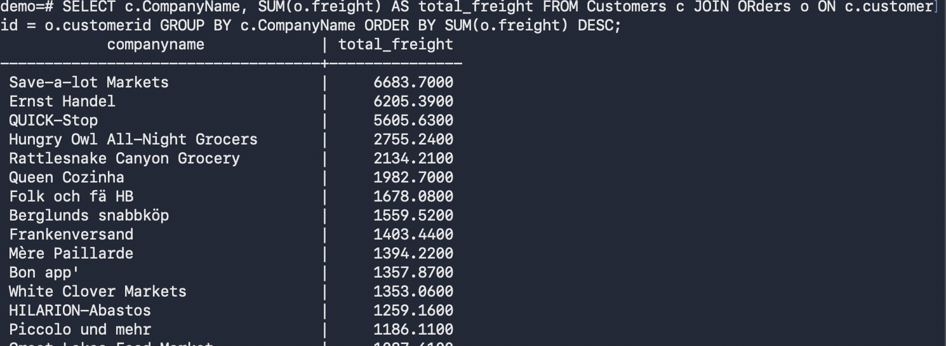

QUESTION 25: Find employees who handled more than 25 orders.
ANSWER:
SELECT e.employeeid, e.firstname, e.lastname, COUNT(o.orderid) AS TOTAL_ORDERS FROM Employees e JOIN ORders o ON e.employeeid = e.employeeid
GROUP BY e.employeeid
HAVING COUNT(o.orderid) > 25;
OUTPUT:
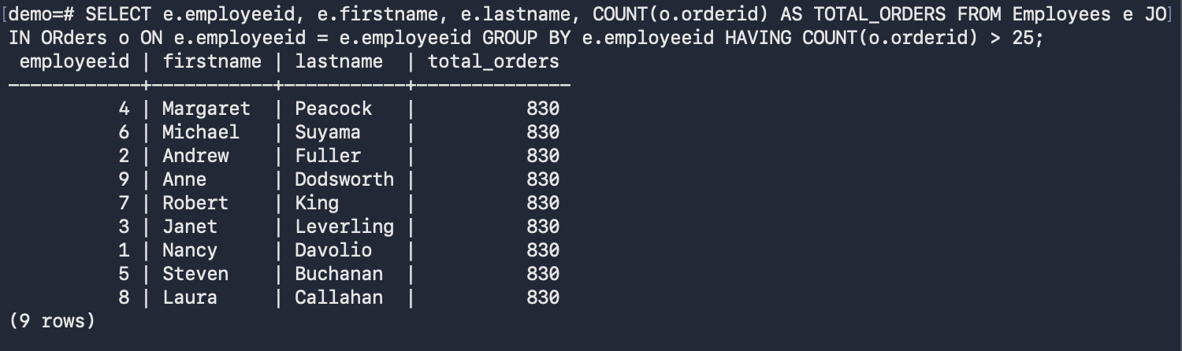

ADVANCED
QUESTION 26: Find total sales amount per order.
ANSWER:
SELECT o.orderid, SUM(od.unitprice) AS total_sales_amt
FROM Orders o JOIN Order_Details od
ON o.orderid = od.orderid
GROUP BY o.orderid;
OUTPUT:
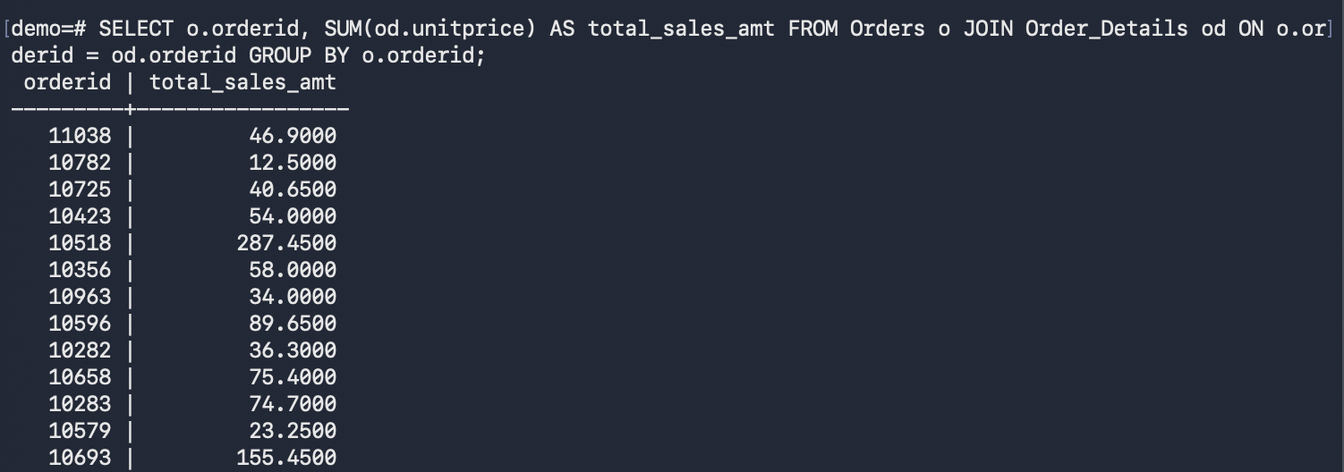

QUESTION 27: Find total sales amount per customer.
ANSWER:
SELECT c.customerid, c.companyname, SUM(od.unitprice * od.quantity) AS Total_Sales FROM Customers c JOIN Orders o ON c.customerid = o.customerid
JOIN order_details od ON o.orderid = od.orderid
GROUP BY c.customerid;

OUTPUT:
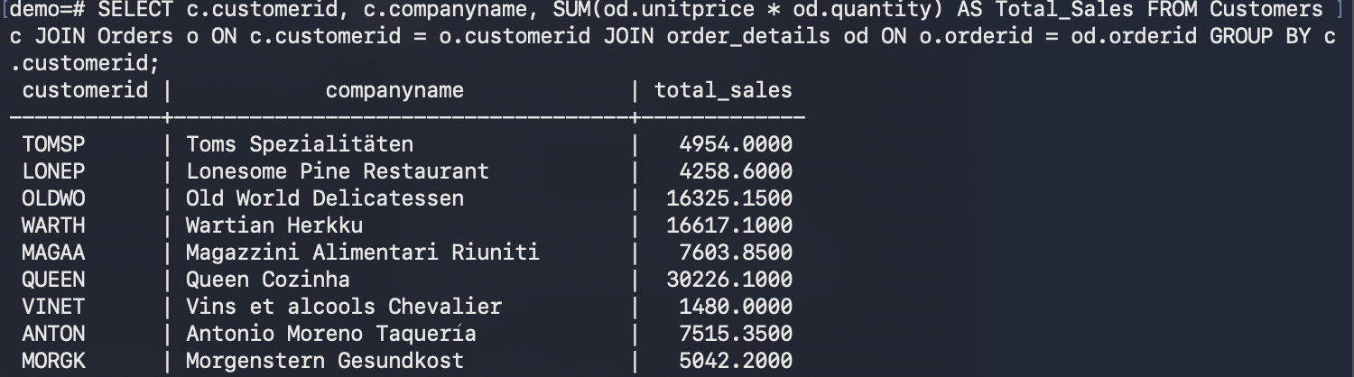
QUESTION 28: Find top 10 products by total quantity sold.
ANSWER:
SELECT p.productid, p.productname, COUNT(o.orderid)
FROM Products p JOIN Order_details o ON p.productid = o.productid
GROUP BY p.productid
ORDER BY COUNT(o.orderid) DESC;
OUTPUT:
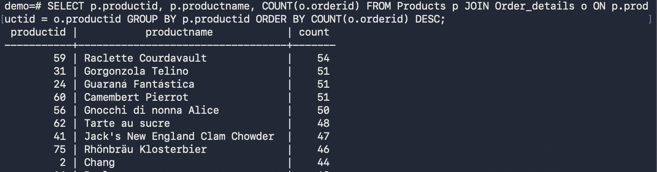

QUESTION 29: Find categories whose total sales are greater than 50000.
ANSWER:
SELECT c.categoryid, c.categoryname, SUM(od.unitprice * od.quantity) AS total_sales FROM categories c JOIN products p ON c.categoryid = p.categoryid
JOIN order_details od ON p.productid = od.productid
GROUP BY c.categoryid
HAVING SUM(od.unitprice * od.quantity) > 5000;

OUTPUT:
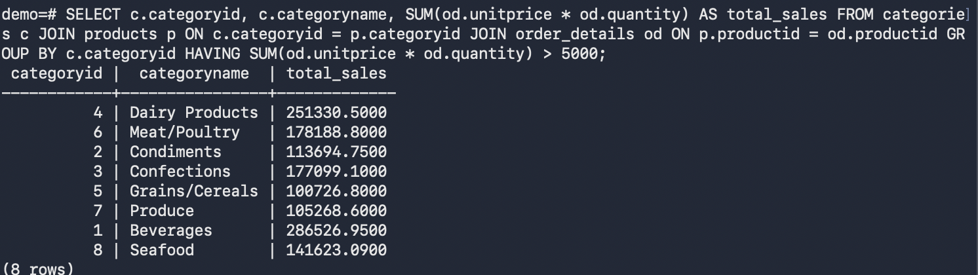

QUESTION 30: Find employees whose total sales are greater than 100000.
ANSWER:
SELECT e.employeeid, e.firstname, e.lastname, SUM(od.unitprice * od.quantity)
FROM employees e JOIN orders o ON e.employeeid = o.employeeid
JOIN order_details od ON o.orderid = od.orderid
GROUP BY e.employeeid
HAVING SUM(od.unitprice * od.quantity) > 100000;

OUTPUT:
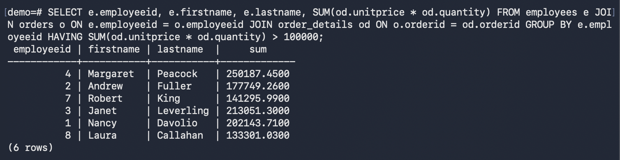

QUESTION 31: Find total sales per country based on customer country.
ANSWER:
SELECT c.country, SUM(od.unitprice * od.quantity) AS total_sales
FROM customers c JOIN orders o ON c.customerid = o.customerid
JOIN order_details od ON o.orderid = od.orderid
GROUP BY c.country;

OUTPUT:
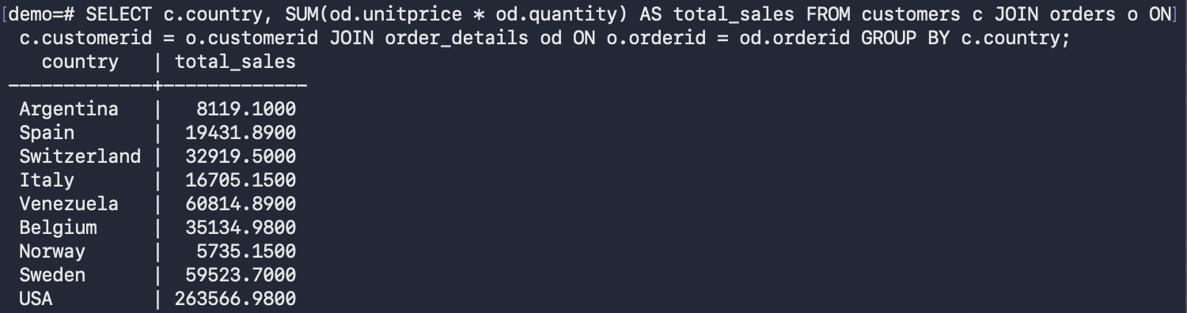
QUESTION 32: Find suppliers whose products generated sales above 30000.
ANSWER:
SELECT s.supplierid, s.companyname, SUM(od.unitprice * od.quantity)
FROM suppliers s JOIN products p ON s.supplierid = p.supplierid
JOIN order_details od ON p.productid = od.productid
GROUP BY s.supplier id
HAVING SUM(od.unitprice * od.quantity) > 30000;

OUTPUT:
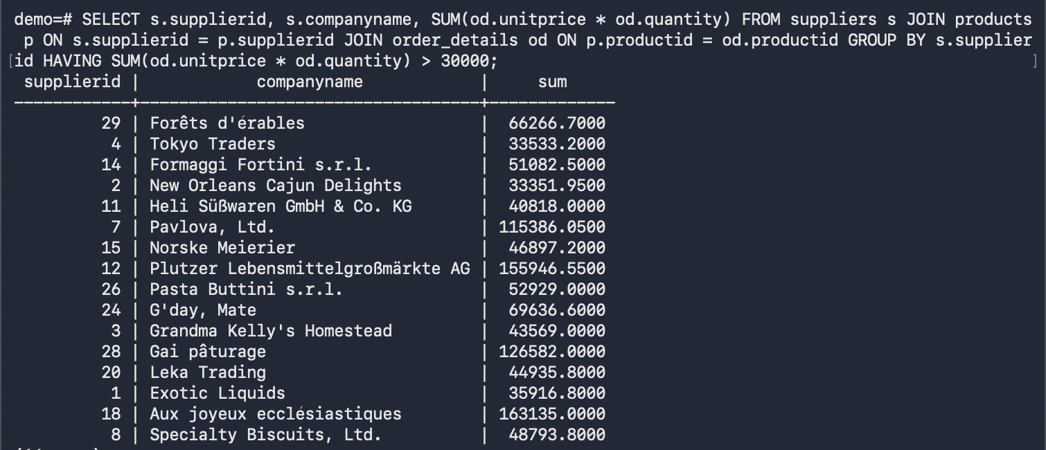

QUESTION 33: Find customers who placed more than 10 orders and sort by order count descending.
ANSWER:
SELECT c.customerid, c.companyname, COUNT(o.orderid)
FROM customers c JOIN orders o ON c.customerid = o.customerid
GROUP BY c.customerid
HAVING COUNT(o.orderid) > 10
ORDER BY COUNT(o.orderid) DESC;

OUTPUT:
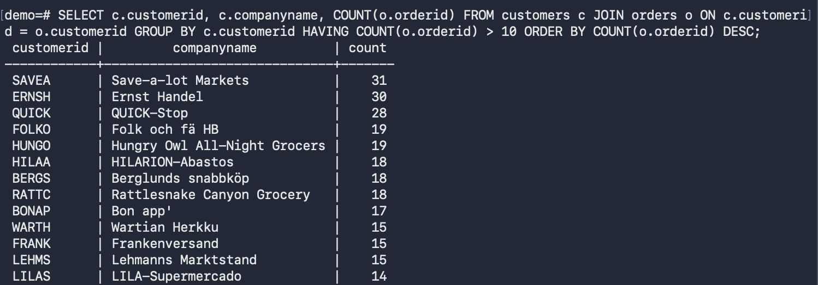

QUESTION 34: Find monthly order count for each year and month.
ANSWER:
SELECT EXTRACT(YEAR FROM OrderDate) as year, EXTRACT(MONTH FROM OrderDate) AS month, COUNT(*) AS order_count
FROM orders
GROUP BY year,month
ORDER BY year,month;
OUTPUT:
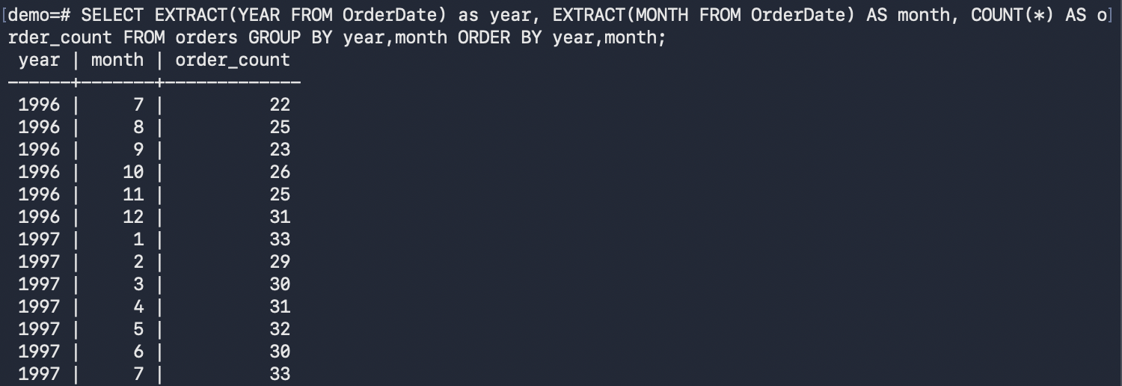

QUESTION 35: Find monthly sales amount ordered by year and month.
ANSWER:
SELECT EXTRACT(YEAR FROM o.orderDate) AS year, EXTRACT(MONTH FROM o.orderDate) AS month, SUM(od.unitPrice * od.Quantity) as Monthly_sales
FROM orders o JOIN order_details od ON o.orderid = od.orderid
GROUP BY year,month
ORDER BY year,month;

OUTPUT:
